Unit 14:

**Homework 4 (65),**

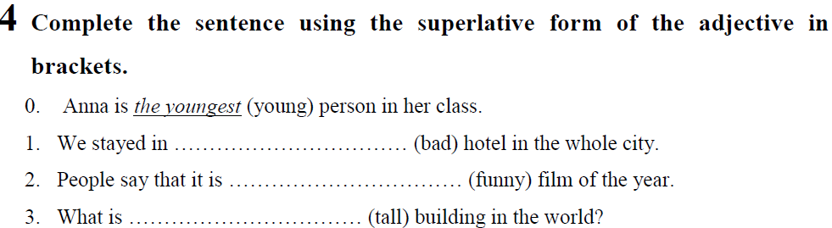

1. the worst 2- the funniest 3- the tallest 4- the best

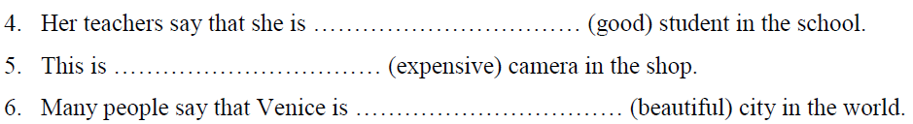

5- the most expensive camera – the most beautiful

**6 (66)**

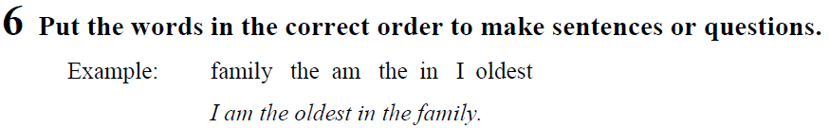

1. sister me my than younger is

1. My sister is younger than me.

2. class who oldest the the in is?

2 who is the oldest in the class?

3. passenger plane is Concorde world fastest the in the

Concorde is the fastest passenger plane in the world

4. book interesting than my your more is book

4. My book is more interesting than your book.

5. bought expensive shop the in watch most Peter the

5 Peter bought the most expensive watch in the shop

6. cheapest buy John shop in the the did watch?

Did John buy the cheapest watch in the shop?

7. difficult German English than more much is

7. German is more difficult than English.

8. weather better today than much yesterday is the

8. The weather today is/ was much better than yesterday.

**7(67)**

|  |  |
| --- | --- |
|  | 1. more carefully 2. better 3. harder 4. more slowly 5. .worse 6. . more effectively 7. more easily 8. faster than |

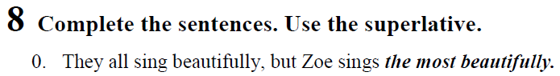

1. Everybody writes imaginatively, but Raymond writes the most imaginatively

2. You all think creatively, but Derek thinks the most creatively

3. We all trained hard, but Robyn trained the hardest……………………………………..

4. It rains heavily here all year, but in July it rains 4.The most heavily ……………………………

5. All her books sell well, but this one sells ,the best…………………………………..

6. They all speak loudly, but Lynn speaks 6 . The most loudly…………………………………….

7. We all played badly, but I played the worst/ best …………………………………………..

8. The kids all eat fast, but Marcel eats the fastest……………………………………….

Writing part 7:

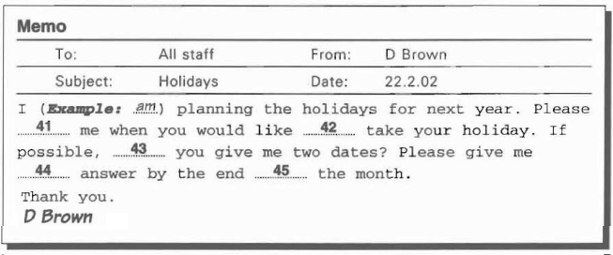

41. tell 42. To 43. Can 44. the 45. Of In the end At the end **of** st : of



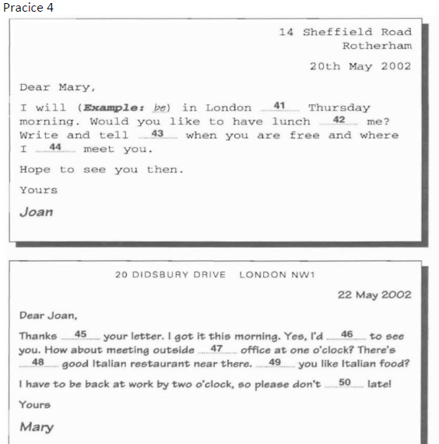

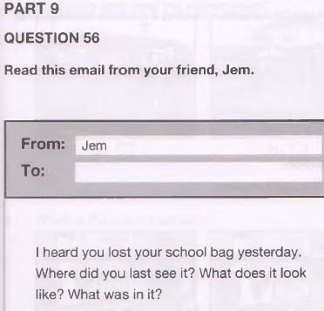

Hi Jem,

I am worried about the school bag I lost yesterday. I last saw it in my class. It is black and small. There were some books and a pen in the bag. I hope to find it soon.

Love,   
nam

See :

Look like

Listening part

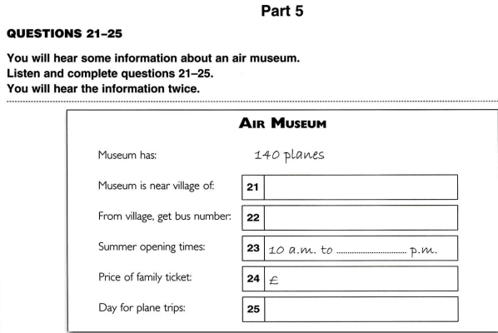

**21. CHERFORD**

**22. 51**

**23. 7.15**

**24. 18**

**25. Sunday**

Listening part 2:

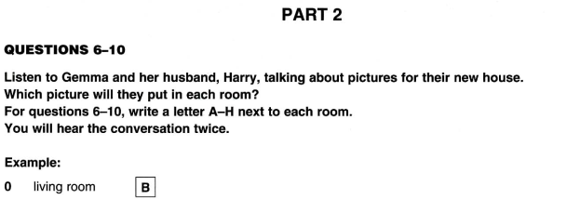

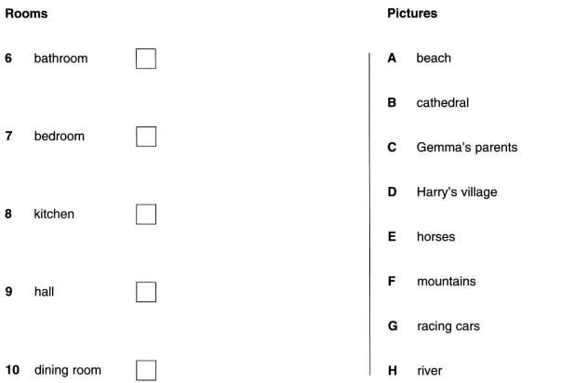

HUONG DAN PHAN DOC SO 5: (CAU 28-35)

* doc va chon Phuong an trac nghiem (A,B & C) dien vao cho trong.
* Chi dc dien MOT tu vao cho trong thoi ( thuong la nhung tu chi y nghia ngu phap)
* Nhin vao cho trong truoc (nhin tu dung truoc va dung sau) ta co the dua ra dc p.a
* Doc cau dung truoc va cau chua no => dua ra pa.
* VIET PA vao phieu tra loi

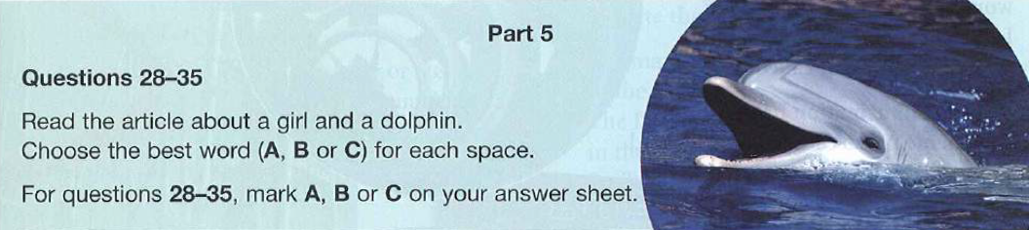

|  |  |
| --- | --- |
| Have a good time  Such + N |  |

|  |  |
| --- | --- |
| By mistake = by accident (tinh co, vo tinh)  Such as  For: doi voi  Like/ Unlike:  Another: mot cai khac  One of the (stt tuyet doi) mot trong nhung ..nhat. |  |